# Brainstorm

## Before you collaborate

A little bit of preparation goes a long way with this session. Here’s what you need to do to get going.

**10 minutes**

**1**

## Define your problem statement

What problem are you trying to solve? Frame your problem as a How Might We statement. This will be the focus of your brainstorm.

**5 minutes**

**2**

## Brainstorm

Write down any ideas that come to mind that address your problem statement.

**10 minutes**

**3**

## Group ideas

Take turns sharing your ideas while clustering similar or related notes as you go. Once all sticky notes have been grouped, give each cluster a sentence-like label. If a cluster is bigger than six sticky notes, try and see if you and break it up into smaller sub-groups.

**20 minutes**

**4**

## Prioritize

Your team should all be on the same page about what's important moving forward. Place your ideas on this grid to determine which ideas are important and which are feasible.

**20 minutes**

# & idea prioritization

PROBLEM STATEMENT

In India many people still uses simple water purifiers for water purification but,due to fast growing urbanisation many impurities are making river water contaminated .So ,it become challenging for authorities to provide people with safe drinking water.

Not only this farmers put fertilizer and

pesticides for their crops but these fertilizer can be washed through the soil by rain to end up in rivers

### Use this template in your own brainstorming sessions so your team can unleash their imagination and start shaping concepts even if you're not sitting in the same room.

**10 minutes** to prepare

**1 hour** to collaborate

1. **Team gathering**

Define who should participate in the session and send an invite. Share relevant information or pre-work ahead.

1. **Set the goal**

Think about the problem you'll be focusing on solving in the brainstorming session.

1. **Learn how to use the facilitation tools**

Use the Facilitation Superpowers to run a happy and

productive session.

[**Open article**](https://support.mural.co/en/articles/2113740-facilitation-superpowers)

##### M.VISHNUPRIYA

using GPRS for tracking the location of highly infected area

P.PENNARASI

UI web application for water monitoring

G.KARTHIGA

wireless network based water parameter data collection

##### S.LAVANYA

app development for detecting pH and turbidity of the river water

app developing for detecting pH

,turbidity and temperature of river water

|  |  |  |  |  |  |
| --- | --- | --- | --- | --- | --- |
| Identifying pH,thershold values | |  | | Lab based water parameter data | |
|  |  | | | |  |
|  | | |  | | |

Algorithm encryption and decryption data of pH and turbidity

measuring device based two nd camera and image processing

UI web application for water monitoring

**2-8 people** recommended

##### Members of brain stroming process

team ID:PTN2022TMID28778

team lead:Garika.yamini priyanka team member 1:Mullu.chandra shekhar team member 2:Akash kumar

team member 3:Siva bharathi

##### Goal of today's discussion topic:

Ideas for solutions in monitoring and controlling river water quality

water pparameters

Real time river water monitoring and contorl system

Lab based water parameter data

Data analysis

arduino and sensor based water parameters monitoring

**Importance**

manual checking of water contamination by paper report

collecting fertilizer and pesticide contaminated water through field site ridges

Biological and chemical changes identification of water by conventional methods

pH ,turbidity

,temperature sensors connected with arudino

If each of these tasks could get done without any difficulty or cost, which would have the most positive impact?

Alerting water contamination to locals through Wi-fi

[**Share template feedback**](https://muralco.typeform.com/to/CiqaHVat?typeform-source=app.mural.co)

**Need some inspiration?**

See a finished version of this template to kickstart your work.

manual work

|  |  |  |  |  |  |
| --- | --- | --- | --- | --- | --- |
|  | | |  | | |
|  |  | | | |  |
| collecting fertilizer and pesticide contaminated water through field site ridges | |  | | manual checking of water contaminated by paper report | |

### Real time information transfer

arduino and sensor based water parameters monitoring

Real time information passage to requried authorities

#### Feasibility

Regardless of their importance, which tasks are more feasible than others? (Cost, time, effort, complexity, etc.)

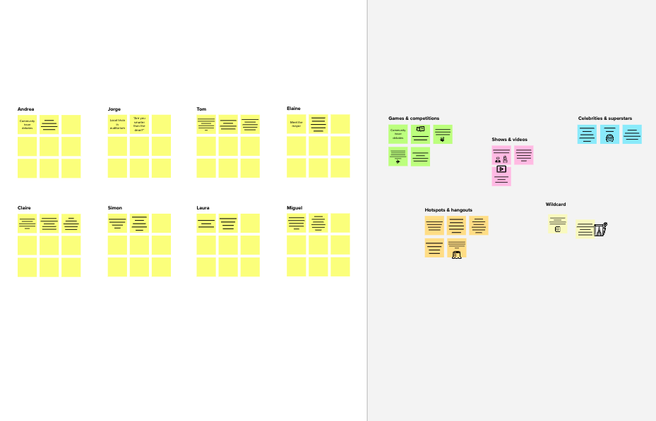

**Template**

[**Open example**](https://app.mural.co/template/e5a93b7b-49f2-48c9-afd7-a635d860eba6/93f1b98d-b2d2-4695-8e85-7e9c0d2fd9b9)